PROJECT REPORT

*on*

STOCK PRICE PREDICTOR

(CSE VI Semester Mini project)

(2022-2023)

**Guided by:**              **Submitted by:**

        Dr. Santosh Kumar                            Ishika goyal

(Resource Person)               Roll No: 2014688

    CSE- Core: VI Sem

    Session:  2022-2023

**Acknowledgement**

Here by we are submitting the project report on **“Stock price pridection”**, as per the scheme of Graphic Era Deemed to be University, Dehradun for VIth semester mini project submission.

In this connection, we would like to express our deep sense of gratitude to our beloved institution Graphic Era Deemed to be University and also I like to express my sincere gratitude and indebtedness to Dr Santosh kumar**.**

I consider it my cardinal duty to express the deepest sense of gratitude to **Mr. Santosh kumar**, for the invaluable guidance extended at every stage and in every possible way.

Finally I am very much thankful to all the faculty members of the Department of Computer Science and Application, friends and our parents for their constant encouragement, support and help throughout the period of project conduction.

Introduction

Stock Price Prediction using machine learning is the process of predicting the future value of a stock traded on a stock exchange for reaping profits. Stock Price Prediction using machine learning is the process of predicting the future value of a stock traded on a stock exchange for reaping profits.

**What is stock?**

A stock (also known as equity) is **a security that represents the ownership of a fraction of a corporation**. This entitles the owner of the stock to a proportion of the corporation's assets and profits equal to how much stock they own. Units of stock are called "shares."

**What is stock price?**

The stock price is **a relative and proportional value of a company's worth**. Therefore, it only represents a percentage change in a company's market cap at any given point in time. Any percentage changes in a stock price will result in an equal percentage change in a company's market cap.

Methodology

1. Build RNN architecture. Here we are importing all the required libraries needed for our model and then we are initialising the training and validation generators.

**Library used**

* Pandas
* Keras
* Numpy
* Pandas
* Pandas_datareader
* Sklearn

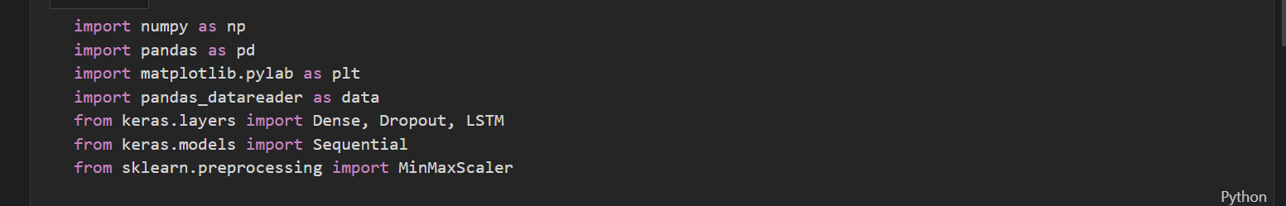

Data set

Here, with the help of pandas_datareader we have read the data for last 10 years and then categories it into 2 sets:

1. 70% as training data
2. 30% as testing data

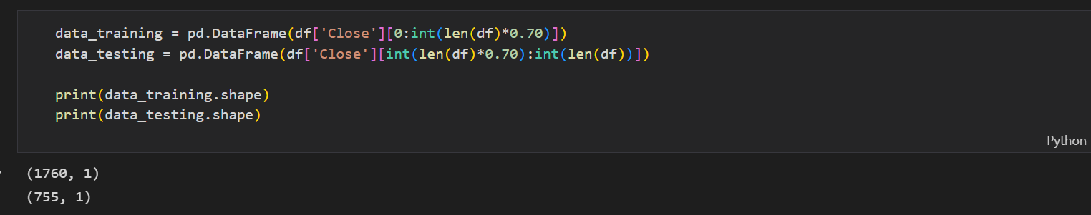

Moving average:

Here we have calculated the 100 days and 200 days moving average if 100 days moving average is above 200 days it indicates up trends and vice versa

Plot whole data

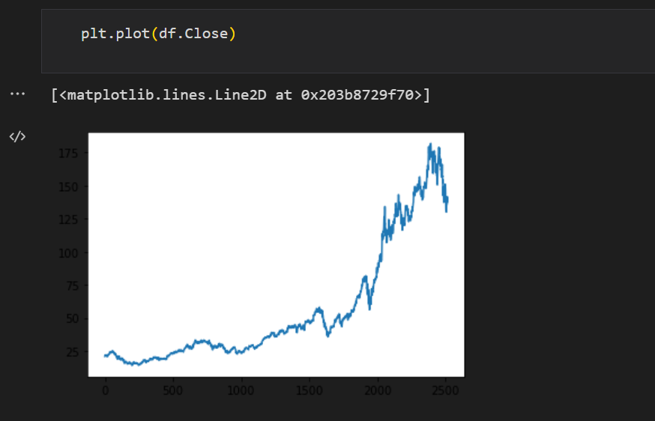

With 100 days moving average

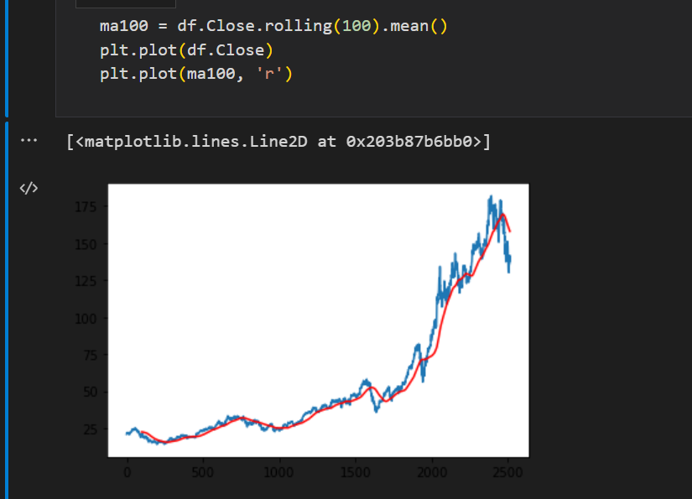

With 200 days moving average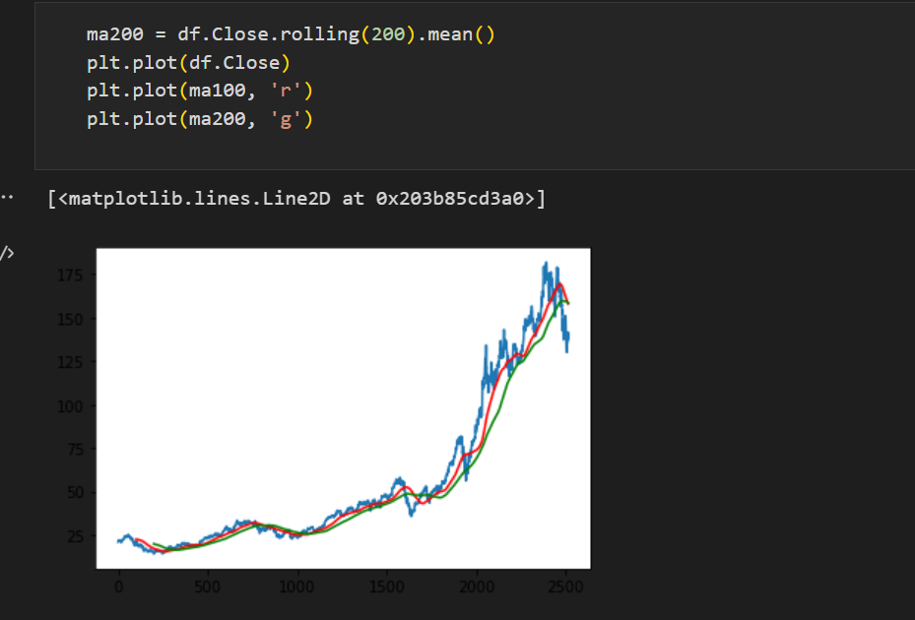

Conclusion

With the help of this model we can predict the price of stocks

But one should not invest the money by using this model as stock price depends on various factors and here we have considered only one.

References

1.GOOGLE.COM

2.YOUTUBE.COM

3.EDUREKA.COM

4.UDEMY

5. Geeksforgeeks.com